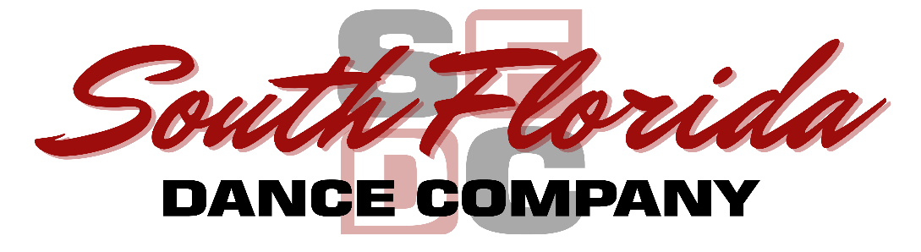
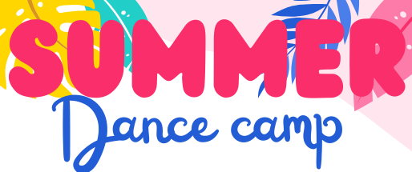

2026 Registration Form - Summer Camp – (Min Age 5)

Child’s Name: __________________________________Date of Birth: __________Age: _____ Grade:_______
Parent/Guardian name: ____________________________ Email: ____________________________________
Phone: __________________________________Cell/other: ________________________________________
Alternate Emergency Contact _______________________________Phone: ____________________________
Allergies/Medical problem: ___________________________________________________________________
*A non-refundable $25 deposit for each week is due with your completed form to reserve your child’s spot and will be applied to the total cost of each camp week(s).
Campers need to pack a lunch, a few snacks, plenty of bottled water. Wear stretchy play clothes and hair must be worn up and out of face. No electronics or toys please, phones must always be kept in student’s bag. Each Monday there will be an activity schedule for the week.
Camp Price:
$150/week Mon-Fri 9:00am-4:00pm
Ext Care 8:00am/5:00pm add $80/week or $20day

Please check the weeks attending and if need extended care ($ amounts to be filled out by SFDC staff)
Billing information:(Last) ________________________________(First)_________________________________
Billing Address: ________________________________City___________________State______Zip__________
Phone: (Home)_______________________(Work)_____________________(Cell)________________________
Card Number _______________________________________________Exp date: ___________ CVV ________
_______Please select if Paying via Step up For Student’s Scholarship

Date and Theme | Select | Ext Care | Week Total $ | Dep. $ | Bal. $
June 8- K-Pop Demon Hunters
June 15- Barbie
June 22- Wicked
July 6- Swiftie’s Unite
July 13- Rio
July 20- Holidays
July 27 Diva Fashion & Spa
August 3- K-Pop Demon Hunters

**Waiver for Barbie Movie**
____ I DO give permission for my child to watch the Barbie movie during Barbie camp week. I understand it is rated PG13 and may have some suggestive content.
____I DO NOT give permission for my child to watch the Barbie movie during Barbie camp week. I understand an animated Barbie movie option rated G will be viewed instead.

Release and Waiver of Liability, Indemnity Agreement, Policies and Guidelines
Please read and initial

In consideration of being permitted to participate in any way in the South Florida Dance Company program
indicated below and/or being permitted to enter for any purpose any restricted area (here in defined as any area where in admittance to the general public is prohibited), the parent(s) and/or legal guardian(s) of the minor participant named below agree:

_____ The parent(s) and/or legal guardian(s) will instruct the minor participant that prior to participating in the dance classes, activity or event, he or she should inspect the facilities and equipment to be used, and if he or she believes anything is unsafe, the participant should immediately advise the officials of such condition and refuse to participate. I understand and agree that, if at any time, I feel anything to be UNSAFE, I will immediately take all precautions to avoid the unsafe area and REFUSE TO PARTICIPATE further.

_____ I/WE fully understand and acknowledge that:
(a) There are risks and dangers associated with participation in dance classes, events
and activities which could result in bodily injury, partial and/or total disability, paralysis and death.
(b) The social and economic losses and/or damages, which could result from these risks and dangers described above, could be severe.
(c) These risks and dangers may be caused by the action, inaction or negligence of the participant or the
action, inaction or negligence of others, including, but not limited to, the Releasees named below.
(d) There may be other risks not known to us or are not reasonably foreseeable at his time.

_____ I/WE accept and assume such risks and responsibility for the losses and/or damages following such injury, disability, paralysis or death, however caused and whether caused in whole or in part by the negligence of the Releasees named below.

_____ I/WE HEREBY RELEASE, WAIVE, DISCHARGE AND COVENANT NOT TO SUE South Florida Dance Company, including its owners, managers, promoters, lessees of premises used to conduct the Dance classes, events or program, premises and event inspectors, underwriters, consultants and others who give recommendations, directions, or instructions to engage in risk evaluation or loss control activities regarding the dance facility or events held at such facility and each of them, their directors, officers, agents, employees, all for the purposes herein referred to as “Releasee”...FROM ALL LIABILITY TO THE UNDERSIGNED, my/our personal representatives, assigns, executors, heirs and next to kin FOR ANY AND ALL CLAIMS, DEMANDS, LOSSES OR DAMAGES AND ANY CLAIMS OR DEMANDS THEREFORE ON ACCOUNT OF ANY INJURY, INCLUDING BUT NOT LIMITED TO THE DEATH OF THE PARTICIPANT OR DAMAGE TO PROPERTY, ARISING OUT OF OR RELATING TO THE EVENT(S) CAUSED OR ALLEGED TO BE CAUSED IN WHOLE OR IN PART BY THE NEGLIGENCE OF THE RELEASEE OR OTHERWISE.

_____ I/WE HEREBY acknowledge that THE ACTIVITIES OF THE EVENT(S) ARE VERY DANGEROUS and involve the risk of serious injury and/or death and/or property damage. Each of THE UNDERSIGNED also expressly acknowledges that INJURIES RECEIVED MAY BE COMPOUNDED OR INCREASED BY NEGLIGENT RESCUE OPERATIONS OR PROCEDURES OF THE RELEASEES.

_____ EACH OF THE UNDERSIGNED further expressly agrees that the foregoing release, waiver, and indemnity agreement is intended to be as broad and inclusive as is permitted by the law of the Province or State in which the event is conducted and that if any portion is held invalid, it is agreed that the balance shall, notwithstanding continue in full legal force and effect.

_____ On behalf of the participant and individually, the undersigned partner(s) and/or legal guardian(s) for the minor participant executes this Waiver and Release. If, despite this release, the participant makes a claim against any of the Releasees, the parent(s) and/or legal guardian(s) will reimburse the Releasee for any money which they have paid to the participant, or on his behalf, and hold them harmless.

______Student(s) hereby represent that he/she is physically able to take the prescribed course of instruction.
______I acknowledge to have read the terms of this agreement in its entirety. I understand that under the terms of this agreement, the Dance Studio obligates itself to furnish the student with competent instruction and suitable facilities for teaching lessons. All class sessions are supervised by qualified personnel trained in the procedures and traditions of dance instruction.
______I understand that tuition is to be paid at the start of camp and is not affected by lesson schedule and/or attendance.
_____ I will faithfully comply with all rules and regulations of South Florida Dance Company facility. I further understand that failure to complete the lessons does not relieve me of my obligation to pay the tuition in full. I also agree that NO tuition will be returned to a student for any reason.
_____All parents and students will always conduct themselves in the utmost appropriate manner, including performances and events outside of the Facility, representing South Florida Dance Company.

_____ South Florida Dance Company may be videotaping and/or taking photographs of our students in class, special events and performances. We use these photographs for publicity purposes, and to show you and community organizations some of the programs at SFDC

Participant/Guardian full name & Address: ___________________________________________________________

__________________________________________________________________________________________________

__________________________________________________________________________________________________

I HAVE READ THIS RELEASE AND WAIVER OF LIABILITY, ASSUMPTION OF RISK AND INDEMNITY AGREEMENT, FULLY UNDERSTAND ITS TERMS, UNDERSTAND THAT I HAVE GIVEN UP SUBSTANTIAL RIGHTS BY SIGNING IT, AND HAVE SIGNED IT FREELY AND VOLUNTARILY WITHOUT ANY INDUCEMENT, ASSURANCE, OR GUARANTEE BEING MADE TO ME AND INTEND MY SIGNATURE TO BE COMPLETE AND UNCONDITIONAL RELEASE OF ALL LIABILITY TO THE GREATEST EXTENT ALLOWED BY LAW.

_______________ ___________________________________ ______________________________________
Date Participant/Parent/Guardian Signature Printed Name

South Florida Dance Company admits students of any race, color, national ethnic origin to all the rights, privileges and activities generally accorded or made available to students at the school. We do not discriminate based on race, color national or ethnic origin in administration of its educational policies, administration policies, and other school administered programs.

